Article on “Contribution of Engineers towards Sustainable Development & Thermal Power” published in Lokmat Times Newspaper dated 15th September, 2020

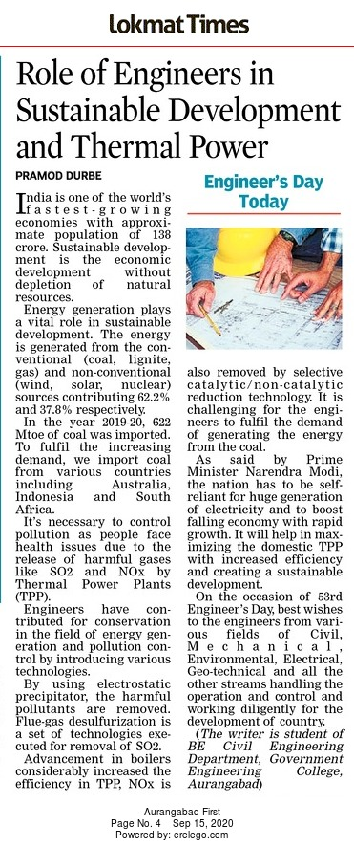
India is one of the world’s fastest-growing economies with approx. population of 138 crore. Sustainable Development is economic development that is conducted without depletion of natural resources. Energy generation plays a vital role in sustainable development. The energy is generated from the conventional (coal, lignite, gas, etc.) & non-conventional (wind, solar, nuclear, etc.) sources contributing 62.2% and 37.8% respectively. In the year 2019-20, 622 Mtoe of coal was imported. To fulfill the increasing demand, we import coal from Australia, Indonesia, South Africa & other countries.

It’s necessary to control pollution as people faces health issues due to the release of harmful gases like SO₂ & NO_{x} by Thermal Power Plants (TPP). Engineers have given their invaluable contribution for conservation in the field of energy generation and pollution control by introducing various technologies. By using electrostatic precipitator, the harmful pollutants are removed. Flue-gas desulfurization is a set of technologies executed for removal of SO₂. Advancement in boilers considerably increased the efficiency in TPP, NO_{x} is also removed by selective catalytic/ non-catalytic reduction technology. As ash content of imported coal is 10 to 20% than the coal produced in the India varies from 20 to 45% so, it is very challengeable for the engineers of our nation to fulfill the demand of generating the energy from the coal.

As said by our Prime Minister nation has to be self-reliant for huge generation of electricity & to boost falling economy with rapid growth. It will help in maximizing the domestic TPP with increased efficiency and creating a sustainable development. On the occasion of 53rd Engineer’s Day, best wishes to the engineers from various fields of Civil, Mechanical, Environmental, Electrical, Geotechnical and all the other streams handling the operation and control and working diligently for the development of country.

Writer Pramod Jeevan Durbe is student of BE (2020-21) Civil Engineering Department, Government Engineering College, Aurangabad.

